

University of Bahrain

College of Information Technology

Department of Computer Engineering

Experiment 3

**Prepared By**

**Name : Ali Redha Ali**

**ID: 20195330**

**Sec: 01**

**Course Number: ITCE340/272**

**Introduction to Fourier transform**

**Objective:**

1. Introducing the Fourier transformation

2. Introducing the linear convolution

**Introduction:**

In this will lab we will learn how to do Fourier transformation in MATLAB

**Procedure**

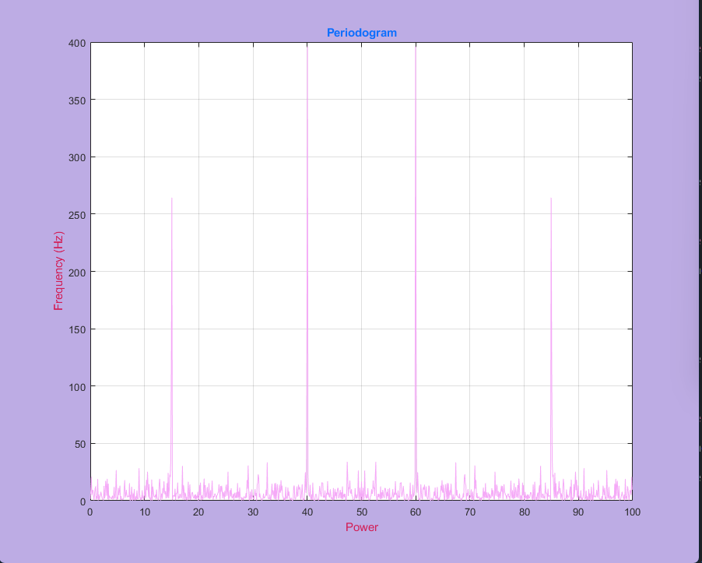

**Conclusion:**

In this lab I learned a lot of things which are

* How to implement signal function in MATLAB
* How to use stem function in MATLAB
* How to use convolution in MATLAB